


DDEX
Standard
Electronic Release Notification Message Suite

Part 3: Choreographies for Cloud-based Storage
Version 1.8

Publication Date: 30th August 2022

Electronic Release Notification Message Suite – Part 3: Choreographies for Cloud-based Storage

Evaluation Licence for DDEX Standards

Subject to your compliance with the terms and conditions of this Agreement, DDEX™ grants you a limited, nonexclusive, non-transferable, non-sublicenseable, royalty-free licence solely to reproduce, distribute within your organisation, and use the DDEX standard specifications (“DDEX Standards”) solely for the purpose of your internal evaluation. You may not make any commercial use of the DDEX Standards under this agreement. No other licences are granted under this agreement.

No representations or warranties (either express or implied) are made or offered by DDEX with regard to the DDEX Standards. In particular, but without limitation, no representations or warranties are made in relation to:

- The suitability or fitness of the standards for any particular purpose;
- The merchantability of the standards;
- The accuracy, completeness, relevance or validity of the standards; or
- The non-infringement of any third party intellectual property rights related to the DDEX Standards.

Accordingly, DDEX and/or its members shall not be liable for any direct, indirect, special, consequential or punitive loss or damages howsoever arising out of or in connection with the use of the standards. IN THE EVENT THAT ANY COURT OF COMPETENT JURISDICTION RENDERS JUDGEMENT AGAINST DDEX AND/OR ITS MEMBERS NOTWITHSTANDING THE ABOVE LIMITATION, THE AGGREGATE LIABILITY TO YOU IN CONNECTION WITH THIS AGREEMENT SHALL IN NO EVENT EXCEED THE AMOUNT OF ONE HUNDRED U.S. DOLLARS (US$ 100.00).

Users of the DDEX Standards are cautioned that it is subject to revision. Users are recommended to use the latest versions, which are available at http://www.ddex.net. The use of outdated versions of the standards is not recommended but may be required by agreement between implementers in particular cases.

© DDEX Page ii

Introduction
This document defines automated message exchange protocols that enable record companies or distributors to reliably communicate standard messages (created in accordance with Part 1 and/or Part 2 of the Electronic Release Notification Message Suite standard (ERN)) and associated resource files to digital music service providers (or DSPs), using cloud-based storage services. It was developed by the member organisations of the Digital Data Exchange, LLC (DDEX). Any organisation wishing to implement this (or any other DDEX standard) is required to apply for an Implementation Licence. The terms of the licence and an application form can be found on https://ddex.net/implem entation/implementation-licence-and-ddex-party-identifiers.
The standard messages contained in Part 1: Definition of Messages, Version 4.3 of the ERN standard provide a mechanism for record companies or distributors to inform DSPs about releases containing one or more resources that can be made available to consumers as electronic products. To aid companies that only wish to communicate a small subset of the types of releases that can be communicated using the NewReleaseMessage from Part 1 of the ERN standard, the structure of the message that should be used for such subsets is defined, depending on the type of the release, in Part 2: Release Profiles, Version 2.3 of the ERN standard.

Part 4: Choreography for Web Services, Version 1.7, 2nd Edition of the ERN standard defines a message exchange protocol using web services.
This Part 3: Choreography for Cloud-based Storage, Version 1.8 defines how record companies or distributors can securely transmit information to DSPs and caters for non-repudiation requirements to be met. While the location and owner of the cloud-based storage server is not defined herein (this is left to be agreed by record companies or distributors and DSPs), the structure of the file servers and names for files are defined by this standard. This part of the ERN standard does not address issues arising from data mismatches detected during the information exchange.

Organisation of the document
This part of the ERN standard has seven clauses and one annex. Clauses 1 and 2 provide a general introduction and the scope of this document as well as the organisation of this part of the ERN standard. Clauses 3 and 4 give a set of normative references as well as terms definitions and abbreviations that are used in this part of the ERN standard. Clauses 5 and 6 then define two profiles for communicating releases with cloud-based storage servers before Clause 7 defines the two messages that support these profiles.
Finally, Annex A provides some release notes.

Normative references
The following normative documents contain provisions, which through reference in this document constitute provisions of this standard. For dated references, subsequent amendments to, or revisions of, any of these publications do not apply.
For undated references, the latest version applies.
- DDEX: Data Dictionary Standard. Latest Version.
- DDEX: Electronic Release Notification Message Suite. Part 1: Definition of Messages, Version 4.3
- DDEX: Electronic Release Notification Message Suite. Part 2: Release Profiles, Version 2.3
- IETF: RfC2026: SSH File Transfer Protocol. October 2001.

Terms and abbreviations
The terms and abbreviations defined in Part 1: Definition of Messages of the Electronic Release Notification Message Suite also apply to this part of the ERN standard. Some of the defined terms in Part 1 of the ERN standard, appear in the text of this part of the ERN standard in lower case, for readability.
In addition, for the purposes of this part of the ERN standard the following terms have the definitions specified in this clause.

Cloud-based Storage
A mechanism by which data, specifically messages defined in the ERN standard as well as files referenced from such messages, are exchanged between record companies or distributors and DSPs. This includes, but is not limited to, (S)FTP servers.

Non-repudiation
The concept of ensuring that a party cannot repudiate, or refute, the sending or receiving of a message and the files referenced from such messages.

Release-by-release profile
  - Choreography
  - File server organisation
  - File naming conventions
  - Examples of server organisation and file naming convention (informative)

Choreography
This clause defines the mechanism by which a record company or distributor can communicate metadata about a release and the resource files that make up that release, one release at a time, to a DSP using:
    - A cloud-based storage server that is hosted by the record company or distributor;
    - A cloud-based storage server that is hosted by the DSP; or
    - A cloud-based storage server that is hosted by a third party.
This specification does not therefore define on whose hardware the files are being stored as this is determined by the bilateral agreement between the record company or distributor and the DSP.
The choreography of the release-by-release profile is as depicted in the diagram in Figure 1 below.

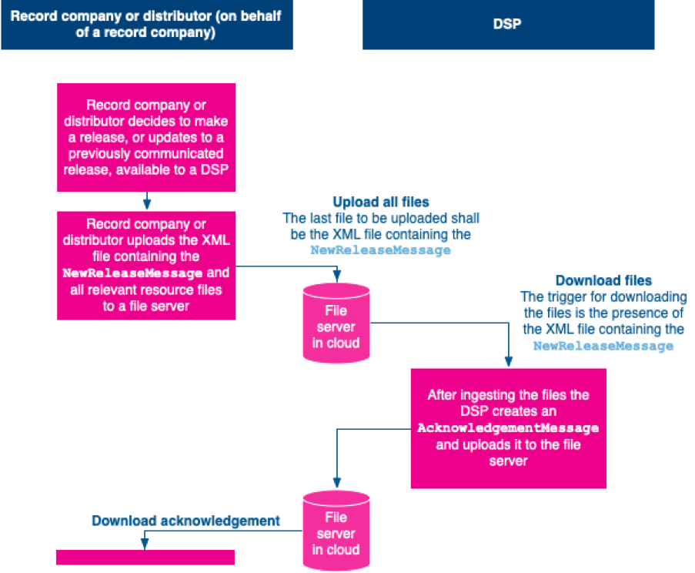

Figure 1 – Release-by-Release Choreography

The record company or distributor and the DSP are responsible to ensuring that the communication is secure.
The NewReleaseMessage referenced in Figure 1 is defined in the latest version of Part 1: Definition of Messages of the Electronic Release Notification Message Suite. If the record company or distributor only wishes to communicate a small subset of the types of releases that can be communicated using the NewReleaseMessage, the structure of the message that should be used for such subsets is defined, depending on the type of the release, in Part 2: Release Profiles Version 2.3 of the ERN standard.
The structure of the AcknowledgementMessage referenced in Figure 1 is set out in the diagram in Figure 2 below:

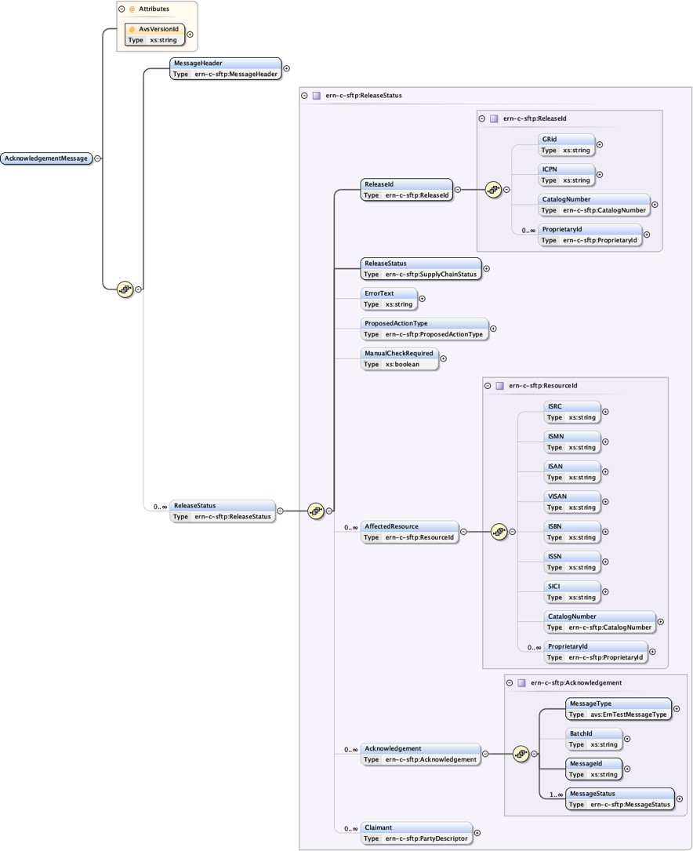
Figure 2 – Structure of AcknowledgementMessage

The server organisation and file naming conventions for the release-by-release profile are defined in Clauses 5.2 and 5.3 below.
This part of the ERN standard does not define when the record company or distributor shall start or finish uploading a NewReleaseMessage and all the associated resource files. Equally, this part of the ERN standard does not define when the DSP shall start or finish its downloading of the NewReleaseMessage and resource files.
In addition to the exchange shown in the diagram in Figure 1 above, and if after the DSP's message ingestion the DSP has sent an Acknowl edgementMessage reporting FileOK, but closer inspection shows deficiencies that were not detected previously, the DSP may use the Ack nowledgementMessage to communicate different status information.

The recipient of the AcknowledgementMessage may remove the AcknowledgementMessage from the file server after an appropriate and mutually agreed period of time. Absent a mutually agreed period of time, the default period is one month.

File server organisation
On the server the NewReleaseMessage relating to a single release shall be placed into a separate folder for that release. The name of the folder shall be made up of the following elements:
- A priority/non-priority indicator (see below), followed by;
- An underscore character, followed by;
- The ReleaseId of the release to which the NewReleaseMessage and resource files relate, followed by;
- An underscore character, followed by;
- The date/time of when the XML file containing the NewReleaseMessage is placed on the server.
The date/time is in the form YYYYMMDDhhmmssnnn with:
- YYYY indicating the year in which the XML file is placed on the file server;
- MM indicating the month in which the XML file is placed on the file server;
- DD indicating the day on which the XML file is placed on the file server;
- hh indicating the hour (in 24 hours) during which the XML file is placed on the file server;
- mm indicating the minute during which the XML file is placed on the file server;
- ss indicating the second during which the XML file is placed on the file server; and
- nnn indicating the millisecond during which the XML file is placed on the file server.
The resource files for the release shall be placed into a subfolder of the release folder called resources/.
The value for the priority indicator may be either:
- P to indicate the release is deemed to be a priority delivery for ingestion by the DSP; or
- N to indicate the release is deemed to be a non-priority delivery.
The meaning of priority in this context is determined by the bilateral agreement between the record company or distributor and the DSP. Mixing non-priority and priority releases in the same delivery is likely to cause confusion on the part of the DSP, especially when no acknowledgements are used. This approach is therefore not recommended.

Once the DSP has downloaded the XML file containing the NewReleaseMessage and the relevant resource files, the AcknowledgementM essage shall be placed into a subfolder of the release folder called acknowledgements/.

File naming conventions
The NewReleaseMessage shall be named as follows:
ReleaseId.Ext

Each resource file shall be named as follows:
Label_ReleaseId_TechnicalResourceId_ResourceType_Hierarchy.Ext

The AcknowledgementMessage shall be named as follows:
ACK_MessageId_YYYYMMDDhhmmssnnn.Ext

The elements of the three file naming conventions above represent the following:
- ReleaseId is the identifier used in the NewReleaseMessage to uniquely identify the release;
- Label is an optional mnemonic token to identify the record company or distributor compiling the release. This element is primarily for human intervention and may only contain letters, digits and dashes (“-“);
- TechnicalResourceId is an optional string, starting with the letter T, that is used in the NewReleaseMessage's relevant XML tag of the same name to uniquely identify the relevant resource or clip. It is permissible that two or more file tags contained in different resource composites point to the same resource file.

For example, one Resource composite may describe a full length sound recording and thus point to a full length resource file, and a second Resource composite may describe a clip that may be exploited by the DSP by using part of the full length sound recording, say, from the 10th second of the sound recording for 30 seconds, and thus needs to point to the same full length resource file;
- ResourceType is an optional element to indicate the type of resource (typically where this is not clear from the nature of Ext eleme nt of the relevant file). This may be a generic value such as SoundRecording or it may be used to designate a more specific type such as CoverArt or even an abbreviation such as WP for a wallpaper resource.
This element is primarily for human intervention. If there are multiple files embodying the same resource, the record company or distributor should use the ResourceType element of the file name (for example, Clip) to differentiate the purpose of each file. For example, a full length sound recording may be embodied in one file and a clip of, say, a few seconds of the full length sound recording embodied in a second file;
- Hierarchy is an optional element to indicate where, in the hierarchy of the release the relevant resource fits. This element should comprise of a sequence of three-digit, zero padded numbers separated by underscores. For example, 008_015 for the 15th resource in the 8th resource group. This Hierarchy element should correspond to the ResourceGroup composite in the NewRele aseMessage;
- YYYYMMDDhhmmssnnn is the date and time that the XML file containing the NewReleaseMessage is placed on the file server.
- MessageId is the identifier used in the NewReleaseMessage, as communicated in the MessageHeader/MessageId tag, being acknowledged.
- Ext is the typical file extension for the resource type (or .xml for the NewReleaseMessage, PurgeReleaseMessage or Acknowl edgementMessage).
A resource file name created in accordance with this clause is only guaranteed to be unique and useful for the duration of the release delivery, that is until an AcknowledgementMessage has been sent by the DSP.
This naming convention is not necessary for machine-to-machine communication but adherence to this convention will aid human intervention for cases where such intervention is necessary.

Examples of server organisation and file naming convention (informative)
The example below shows a delivery of two releases both with two resource files associated with them. The first release has already been acknowledged by the DSP, the second has not. The example does not use the ResourceType component of the file name. The delivery of both releases is a "normal" delivery (as opposed to a priority one).
N_A10301A0001887532A_20100517154800000/ A10301A0001887532A.xml
resources/ A10301A0001887532A_T1.mp3 A10301A0001887532A_T2.jpg
N_A10301A00017EG98F_20100517155422000/ A10301A00017EG98F.xml
resources/ A10301A00017EG98F_T1_001.mp4 A10301A00017EG98F_T2_2.jpg
acknowledgements/ ACK_A10301A0001887532A_20100517154800000.xml

The example below shows one delivery where one of the three resources has been taken from a different release.
N_A10301A0001887532A_20100517154800000/ A10301A0001887532A.xml
resources/ A10301A0001887532A_T1.mp3 A21412B1112998643B_T2.mp3 A10301A0001887532A_T3.jpg

The example below shows a delivery where three separate files of one resource is provided. The three files are a video file, an audio file and a colour space information file.

A_A10301A0001887532A_20100517154800000/ A10301A0001887532A.xml
resources/ A10301A0001887532A_T2_video_.bit A10301A0001887532A_T2_audio.bit A10301A0001887532A_T2_color.bit

Batch profile
  - Choreography
  - Batch constraints
  - File server organisation
  - File naming conventions
  - Example of server organisation and file naming convention (informative)

Choreography
This clause defines the mechanism by which a record company or distributor can communicate batches of metadata and the resource files that make up the releases in the batch to a DSP, using:
    - A cloud-based storage server that is hosted by the record company or distributor;
    - A cloud-based storage server that is hosted by the DSP; or
    - A cloud-based storage server that is hosted by a third party.
    - This specification does not therefore define on whose hardware the files are being stored as this is determined by the bilateral agreement between the record company or distributor and the DSP.
The choreography of the batch profile is depicted in the diagram in Figure 3, below:

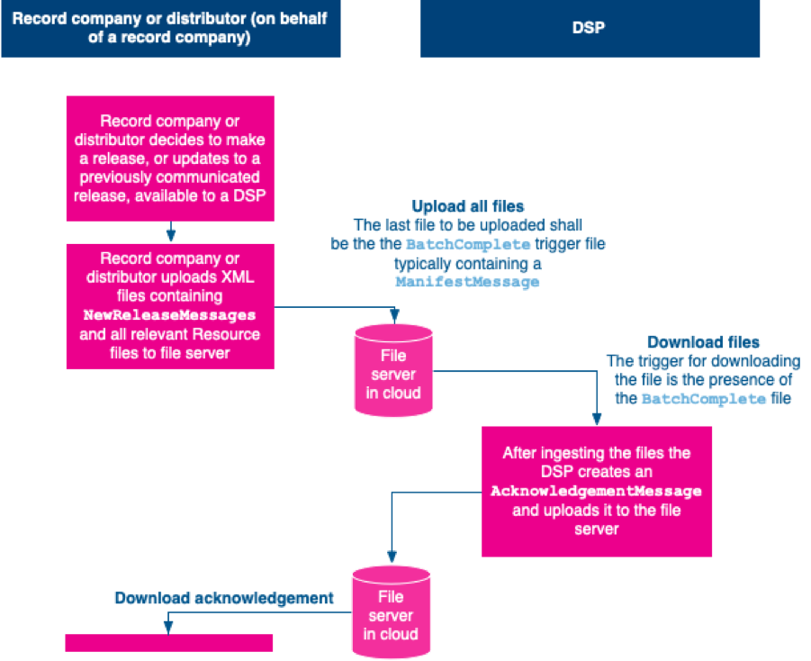

Figure 3 – Batched Choreography

The record company or distributor and the DSP are responsible to ensuring that the communication is secure.
The NewReleaseMessage and the AcknowledgementMessage referenced in Figure 3 are the same as those used in the release-by-release profile.

The structure of the NewReleaseMessages communicated using this batch profile shall follow the release profile agreed as appropriate for the communicated release(s) as defined in Part 2: Release Profiles of the ERN standard.
The file server organisation and file naming conventions for the SFTP batch profile are defined in Clauses 6.3 and 6.4 below.

This part of the ERN standard does not define when the record company or distributor shall start or finish the uploading of the next batch of N ewReleaseMessage (including all resource files). Equally, this part of the ERN standard does not define when the DSP shall start or finish its download of the files.

In addition to the exchange shown in the diagram in Figure 3 above, if after ingestion by the DSP it has sent an AcknowledgementMessage reporting FileOK but closer inspection shows deficiencies that were not detected previously the DSP may use the AcknowledgementMess age to communicate different status information.
The recipient of the AcknowledgementMessage may remove that message from the file server after an appropriate and mutually agreed period of time. The default period is one month. The AcknowledgementMessage is defined in this standard.
When a record company or distributor communicates metadata and resource files using the batch profile the trigger to indicate to the DSP that a batch is completely loaded is the additional loading of a ManifestMessage. The structure of the ManifestMessage is set out in the diagram in Figure 4 below and defined in this part of the ERN standard.
Instead of using a ManifestMessage, in exceptional circumstances, such as for the support of human intervention, it is permissible for the record company or distributor to use a zero-byte semaphore file to indicate the upload is complete. The use of such a semaphore file may alert operational users on the DSP's side, indicating the manual nature of the override.

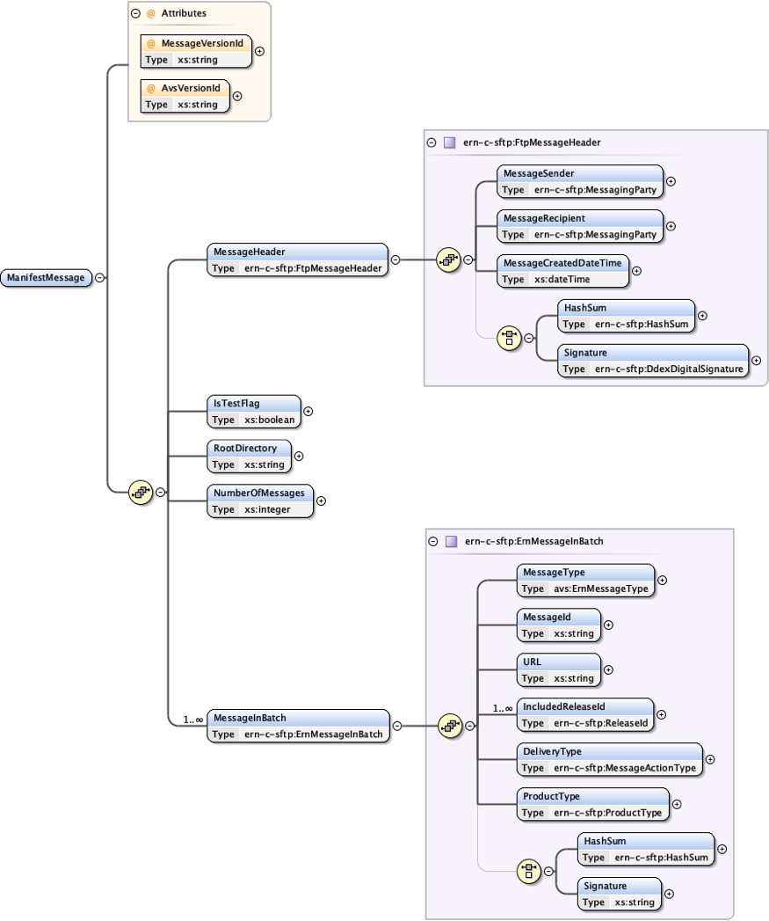

Figure 3 – Structure of ManifestMessage

Batch constraints
The maximum size of a batch is not defined in this part of the ERN standard but shall be determined by the bilateral agreement between the record company or distributor and the DSP before using this profile. It is not permitted to include a NewReleaseMessage and the resource filed relating to a particular release more than once in a single batch.
If the record company or distributor wants to have several batches “open” at the same time, it needs to ensure that no release is contained in

more than one open batch.
The maximum time a batch may be kept “open” is determined by the bilateral agreement between the record company or distributor and the DSP.

To ensure sequential processing, a batch is identified by the date and time it is first placed on the server in the form YYYYMMDDhhmmssnnn w ith:
- YYYY indicating the year in which the batch is placed on the file server;
- MM indicating the month in which the batch is placed on the file server;
- DD indicating the day on which the batch is placed on the file server;
- hh indicating the hour (in 24 hours) during which the batch is placed on the file server;
- mm indicating the minute during which the batch is placed on the file server;
- ss indicating the second during which the batch is placed on the file server; and
- nnn indicating the millisecond during which the batch is placed on the file server.
The record company or distributor shall ensure that, for each of the DSPs to which it is communicating, a unique BatchId is associated with each batch.

File server organisation
On the file server each batch shall be placed into a separate folder for that batch. The name of the folder shall be made up of a priority/non-priority indicator (see below), followed by an underscore character, followed by the BatchId.
The NewReleaseMessage relating to each release within that batch shall be placed into a separate folder which is named using the Releas eId of the release to which the NewReleaseMessage relates. The resource files relating to that release shall be placed into a subfolder of the release folder, called resources/.
If possible, the ReleaseId used should be a GRid as defined in the GRid standard. However, if that is not possible, the different unique identifier to be used is determined by the bilateral agreement between the record company or distributor and the DSP.
The value for the priority indicator may be either:
- P to indicate all or some of releases in the batch are deemed to be a priority delivery, for ingestion by the DSP; or
- N to indicate that none of the releases in the batch are deemed to be priority delivery for ingestion by the DSP.
The meaning of priority in this context is determined by the bilateral agreement between the record company or distributor and the DSP. Mixing non-priority, partial priority and priority releases within the same batch delivery is likely to cause confusion on the part of the DSP, especially when no acknowledgements are used. This approach is therefore not recommended.
The ManifestMessage shall be placed into the root folder of the batch.
Once the DSP has downloaded the batch the AcknowledgementMessage shall be placed into a into a subfolder of the batch folder called a cknowledgements/.

File naming conventions
The file naming convention used in the batch profile for the NewReleaseMessage and the relevant resource files are the same as for the release-by-release profile and described in Clause 5.3.

The file naming convention of the ManifestMessage for each batch shall be the string BatchComplete_ followed by the BatchId (as defined above) and the .xml file extension. The same file name applies to the zero-byte semaphore file.
The file name of the AcknowledgementMessage for each batch shall be the string ACK_ followed by an undersore character, the date and time that the batch is placed on the FTP server, an underscore character, the ReleaseId, an underscore, the BatchId and .xml file extension.

The AcknowledgementMessage shall be named using the same ERN Message ID as used in the ReleaseId component of the enclosing folder’s name with an .xml file extension.
Each resource file should be named as described in Clause 5.3.

Example of server organisation and file naming convention (informative)
The example below shows a delivery of one priority batch with two releases both with two resource files associated with them. The batch is not yet acknowledged.

P_20100310130322000/ A10301A0001887532A/
A10301A0001887532A.xml
resources/ A10301A0001887532A_T1_001.mp3 A10301A0001887532A_T2_001.jpg
A10301A00017EG98F/ A10301A00017EG98F.xml
resources/ A10301A00017EG98F_T1_001.mp4 A10301A00017EG98F_T2_002.mp3
BatchComplete_20100310130322000.xml acknowledgements/
<empty>

Message definition
  - Introduction
  - Namespace
  - Allowed value sets

Introduction
The messages defined in this part of the ERN standard are depicted in Figure 2 and Figure 3 above.
Further information is provided in the XML Schema Definition file for this part of the ERN standard, which can be found here.
Specific business processes between a record company or distributor and the DSP may require additional conformance rules. These are, however, not part of this part of the ERN standard and are determined by the bilateral agreement between the record company or distributor and the DSP.

Namespace
The full namespace for the XML Schema document for this part of the ERN standard is
http://ddex.net/xml/ern-c-sftp/18

All messages developed within DDEX use a common set of terms each of which has a precise definition. The terms with their definitions are contained in the DDEX data dictionary available here.

Allowed value sets
The messages defined in this standard make extensive use of allowed value sets. These allowed value sets are used in all DDEX standards and DDEX provides an XML Schema Definition file which lists all the definitions for all the allowed values in all of the allowed value sets. The allowed value sets, the allowed values and their definitions are also contained in the DDEX data dictionary available from ddex.net.

The messages defined in this standard contain a mandatory AvsVersionId XML attribute. The AvsVersionId at the publication date of this standard is 3. The full namespace for the XML Schema document for the allowed value sets is:
http://ddex.net/xml/allowed-value-sets

DDEX may update the list of allowed value sets over time and this may therefore require the AvsVersionId number to be increased. When this happens, the new current AvsVersionId will be publicised on the DDEX Knowledge Base. Any such updated version of the allowed value sets which is issued on a date after the publication date of this standard forms part of this standard.

Annex A Release Notes (informative)

Version 1.8 has generalised this part of the ERN standard to all types of cloud-based data storage servers whereas the versions up to version 1.7 supported SFTP only. Version 1.8 also removes support for the hard disk delivery profile and changes the file naming convention to support multiple resource files for a single Primary Resource.

Version 1.7 harmonised the communication of acknowledgements and release status between the SFTP and web service choreographies.

Version 1.6.1 fixed a bug in the description of the file naming convention.

Version 1.6 split the choreography for the communication of ERN messages (originally in one part of the ERN standard) into an SFTP profile (defined in this part of the ERN standard) and a web service profile (defined in Part 4 of the ERN standard). The SFTP profile now also supports the signalling of priority deliveries on file-system level. It also removes the provision that permits the communication of release information using insecure FTP servers.

Version 1.5 introduced small changes to the file naming convention and aligned it with current practice across all DDEX standards.

Version 1.4 simplified the process of acknowledging the ingestion of a release or batch of releases using the FTP profile by providing a simplified acknowledgement message. It also added error codes and makes sending acknowledgements mandatory. It also changed the file name convention for acknowledgements to better support the newly introduced limited life-span of acknowledgements.

Version 1.3 supported hard disk deliveries and corrected the naming convention for the manifest file, indicating that the batch is complete from Manifest_* to batch_complete_*.
Version 1.2 enabled the InformationAboutDeliveredAndAvailableReleasesMessageCall (previously known as InformationAb outAvailableReleasesMessageCall) to be used by a record company or distributor as an audit tool. It also allowed error messages be communicated to a web service caller and enables a DSP to ask for the “next release” without specifying what release that should be.
Version 1.2 also added a MessageActionType into the InformationAboutAvailableReleasesReportMessage and made the Mess ageType, in the same composite, optional. In addition, some clarifications were added and unnecessary clauses were removed.
Version 1.1 enabled the ability for humans to intervene, when needed, into a feed. Other changes were made to enable a more streamlined machine-to-machine communication. However, since DDEX is not aware of any implementation of the ECHO version 1.0 standard (as this part of the ERN standard was previously known), the details of these changes are not listed here.

